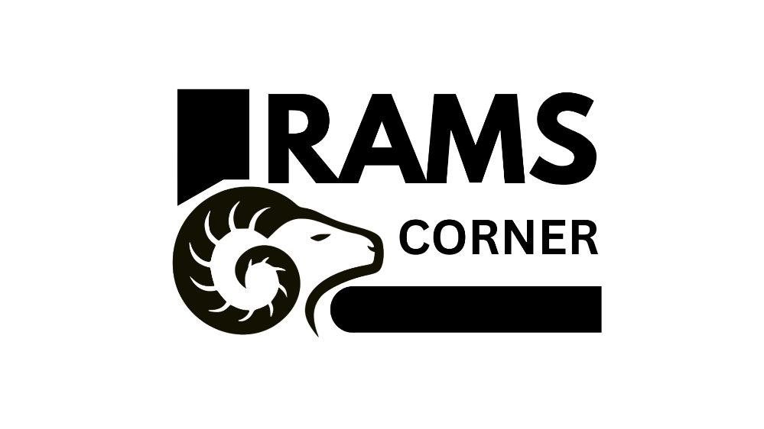

## **RAMS CORNER**

## NACOR INDUSTRIES

# QUALITY MANAGEMENT PLAN

### Version 1.0

### 06/02/2023

# Document Control

## Document Information

|  |  |
| --- | --- |
|  | **Information** |
| Document Id | *NCRI-01* |
| Document Owner | *Nacor Industries* |
| Issue Date | *06/02/2023* |
| Last Saved Date | *06/02/2023* |
| File Name | *Nacor Industries – Quality Management Plan* |

## Document History

|  |  |  |
| --- | --- | --- |
| **Version** | **Issue Date** | **Changes** |
| *1.0* | *05/16//2022* | *[objectives,4,para 1-4]* |
| 1.1 | 05/18/2022 | [general problem,10,para 1] |
| 2.0 | 11/15/22 | [UI/UX,Lo-Fi model improvement,50]  [Grammar Corrections,20]  [Diagram attributes and cardinality improvement]  [removing DFD kbl,32] |
| 3.0 |  | [rephrase objectives,4,para 1-4] |

## Document Approvals

|  |  |  |  |
| --- | --- | --- | --- |
| **Role** | **Name©** | **Signature** | **Date** |
| Project Sponsor | Jojo F. Castillo |  |  |
| Project Review Group | Nacor Industries |  |  |
| Project Manager© | Ruth Morallos |  |  |
| Quality Manager | Kieyl D. Ponce |  |  |

**Table of Contents**

RAMS Corner i

Nacor Industries i

QUALITY MANAGEMENT PLAN i

Version <1.0> i

06/02/2023 i

Document Control i

Document Information i

Document History i

Document Approvals i

Template Guide 1

QUALITY STANDARDS 2

QUALITY OBJECTIVES 2

QUALITY ROLES AND RESPONSIBILITIES 2

DELIVERABLEs AND PROCESSES SUBJECT TO QUALITY REVIEW 2

QUALITY CONTROL APPROACH 3

Appendices 4

DOWNLOAD MORE PROJECT TEMPLATES 4

# Template Guide

***How to use this template***

*This is a guide to the common sections included in a Procurement management plan. Sections may be added, removed, or amended to suit your project. Example tables have been added (where relevant**) these are just a suggestion; you may decide to format these sections differently.*

*Text in Blue italics is designed to assist you in completing the template. Delete this text before sharing the final document.*

# QUALITY STANDARDS

*<Document any industry or product quality standards that apply to your project. For example, International Organization Standardization (ISO), World Wide Web Consortium (W3C) and Institute of Electrical and Electronics Engineers (IEEE)>.*

# QUALITY OBJECTIVES

*<Note down the quality targets for the overall project. Be as specific as you can be and include how you will measure if the metric has been met. You can use a separate Quality Metrics table to enter the detailed metrics for each deliverable>.*

|  |  |
| --- | --- |
| **Metric or Specification** | **Measure** |
| *Delivery to scope.* | *The deliverables were always set and followed on time and is scheduled always a week or at least 3 days before the deadline to be checked if it adhered quality standards and the Agile – Scrum methodology implemented in the project’s creation and development.* |
| *Delivery on time* | *Baseline schedule +/- change orders versus actual dates.* |
| *Delivery on budget* | *Actual costs +/- change orders versus budget.* |
| *Adherence to ACME project methodology* | *PMO audit comparison of method versus project management deliverables.* |

# QUALITY ROLES AND RESPONSIBILITIES

*<Note down the roles and responsibilities that are needed to manage quality on the project>.*

|  |  |
| --- | --- |
| **Roles** | **Responsibilities** |
| *Quality Manager* | *Oversight of quality control on the project. This role will be fulfilled by the PMO Manager.* |
| *Project Manager* | *Scheduling and management of quality control activities.* |
| *Developers* | *Comply with quality standards and participate in quality control activities.* |
|  |  |

# DELIVERABLEs AND PROCESSES SUBJECT TO QUALITY REVIEW

*<List the project deliverables and processes that will be quality reviewed. For example,>*

|  |  |
| --- | --- |
| **Deliverable or process that will reviewed** | **Details of quality review** |
| *Risk Management* | *Part of the PMO project audit process* |
| *Testing including UAT* | *Part of the PMO project audit process* |
| *Software access and permissions* | *HTTS to transmit and receive data.*  *TLS 1.2 encrypt.*  *API require OAuth 2.0* |
| *Website accessibility* | *Meet WCAG 2.0.* |
|  |  |

# QUALITY CONTROL APPROACH

*<Describe when and how quality will be checked. For example,>*

|  |  |  |  |
| --- | --- | --- | --- |
| **Quality control process** | **Milestones** | **Owner** | **Documentation** |
| *PMO project audit process* | *Startup phase audit (June 2021)*  *Test readiness (Aug 2021)*  *Post project review (Sept 2021)* | *PMO manager* | */pmo/quality/*  *project-audit-process.pdf* |
| *WACG 2.0 audit* | *Audit (Aug 2021)*  *Complete recommendations (Sept 2021)* | *Accessibility test team ACME Co.* | *https://www.w3.org/*  *TR/WCAG20/* |
|  |  |  |  |

# Appendices

*<Include any additional information, e.g., copies of forms, process diagrams or policy documents here. Include a link to the Quality Metrics if applicable.>*